Print the document. Draw the hands on the clocks.
Show the document to your teacher.

What time is it?
1 It is two o’clock.
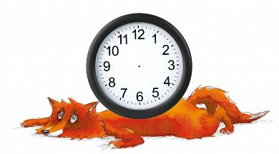

2 It is five o’clock.
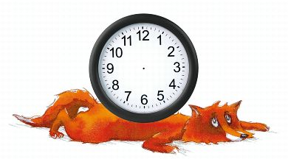
3 It is six o’clock.

4 It is ten o’clock.

5 It is one o’clock.

6 It is seven o’clock.

